**Final Report**

In the dynamic landscape of real estate, the quest for accurate predictions forms the bedrock of informed decision-making for both buyers and sellers. Leveraging data-driven methodologies, our program delves into the rich tapestry of New York housing data to empower individuals in their quest for the perfect abode. At the heart of our endeavor lies a nuanced understanding of the Mean Squared Error (MSE) – a linchpin in evaluating predictive accuracy in regression analysis.

The MSE, a cornerstone metric in our predictive modeling framework, encapsulates the average squared difference between actual and predicted house prices. As our algorithm sifts through the myriad data points, the MSE emerges as a beacon, illuminating the path towards precision in price prognostication. With an MSE approximating 29,129,944,276.34362, our program unearths the nuanced discrepancies between predicted and observed values, offering a granular view into the efficacy of our predictive model.

To distill the essence of predictive accuracy, we turn to the Root Mean Squared Error (RMSE), a derivative of the MSE. Like a compass guiding a ship through uncharted waters, the RMSE furnishes stakeholders with a comprehensive measure of predictive error, grounded in the very units of the target variable. With an RMSE hovering around 170,701.71 units, our program delivers a holistic appraisal of predictive efficacy, steering users towards well-informed decisions in the bustling real estate landscape of New York.

However, interpreting the MSE and RMSE transcends numerical values; it necessitates a nuanced understanding of the domain's intricacies. In the labyrinthine corridors of New York's real estate market, where every borough pulsates with its unique rhythm, a high MSE/RMSE may not necessarily portend failure. Instead, it serves as a clarion call for contextual analysis, urging stakeholders to consider the idiosyncrasies of the market and the multifarious factors influencing property prices.

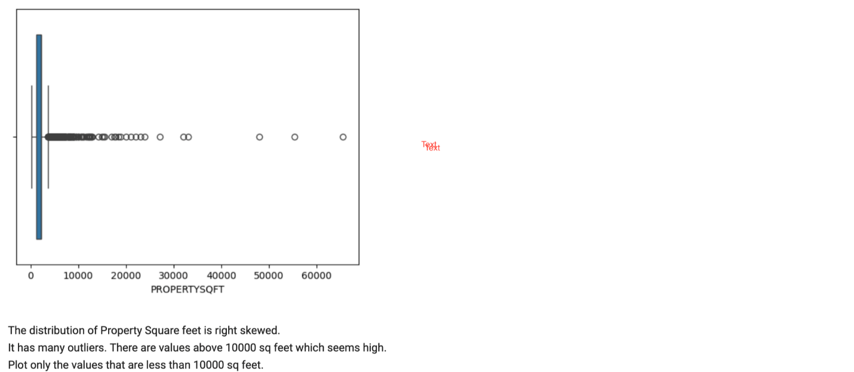Beyond the esoteric realm of error metrics lies the crucible of data cleaning and preprocessing – the unsung heroes in our quest for predictive prowess. Rigorous data cleansing, marked by the meticulous removal of extraneous columns and the harmonization of data types, forms the bedrock upon which our predictive model stands. With each data point meticulously curated, our program navigates the labyrinth of New York's housing data with unparalleled precision, empowering users to make informed decisions with confidence.

As the program unfurls its wings, splitting the dataset into training and testing sets heralds a new dawn in predictive analytics. Through this bifurcation, we bestow upon our model the gift of foresight, enabling it to traverse uncharted territories with aplomb. Armed with insights gleaned from testing data, our program emerges as a beacon of reliability, guiding users towards the abode of their dreams with unwavering precision.

In summation, the Mean Squared Error emerges as a lodestar in our journey towards predictive accuracy in New York's real estate landscape. Through its nuanced interpretation and meticulous application, our program transcends the confines of mere numerical metrics, ushering stakeholders into a realm where data-driven decisions reign supreme. As users embark on their quest for the perfect home, our program stands as a steadfast companion, navigating the turbulent waters of real estate with unwavering precision and foresight.

In the bustling metropolis of New York, where the real estate market pulsates with energy and opportunity, our program stands as a beacon of insight, guiding individuals on their quest for the perfect abode. Central to our mission is the meticulous curation of data – a process fraught with intricacies and nuances that shape the very foundation of predictive accuracy. As we embark on this journey, let us delve into the labyrinthine corridors of data cleaning and visualization, unraveling the tapestry of insights that underpin our predictive model.

The journey begins with a trove of data, meticulously curated from the myriad sources that constitute New York's real estate landscape. Yet, within this wealth of information lies a veritable treasure trove of insights waiting to be unearthed. Armed with the tools of data cleaning and visualization, our program embarks on the arduous task of distilling signal from noise, illuminating the path towards predictive accuracy.

Data cleaning, the linchpin of our analysis, serves as the crucible wherein raw data is refined into actionable insights. With surgical precision, extraneous columns are pruned from the dataset, casting aside the superfluous detritus that obscures the true essence of the data. Yet, the journey does not end here; for amidst the labyrinthine corridors of data lie hidden gems waiting to be discovered.

the art of transforming raw data into visual narratives that elucidate patterns, trends, and anomalies. Armed with a panoply of visualization techniques, our program embarks on a voyage of discovery, casting light upon the hidden intricacies of New York's real estate market. From scatter plots that unveil the relationship between price and square footage to heatmaps that delineate spatial patterns in property distribution, each visualization serves as a window into the soul of the data, guiding our decisions with unwavering clarity.

Through the judicious application of statistical techniques and machine learning algorithms, we unravel the hidden patterns that underpin New York's real estate market, guiding stakeholders towards well-informed decisions with unwavering precision.

